The SMART Recovery Teen & Youth Program

Addiction Recovery Help for Teens and Young Adults
- Are drugs, alcohol, or other behaviors getting in the way of what you really want?
- Are you feeling pressured by parents, friends, and others?
- SMART Recovery can help you take CONTROL of your life.
- SMART Recovery provides tools and resources; YOU have the power to change YOUR behaviors.
Leave the hassles of addiction behind, and work to claim your own life!
- What is SMART Recovery?

SMART stands for...

• Self
• Management
• And
• Recovery
• Training
- The SMART Recovery 4-Point Program®

SMART Recovery is based upon a 4-Point Program that uses a variety of tools and techniques:

Point 1- Building and Maintaining Motivation
This is where you find your REASONS to change, and the motivation to keep going!

Point 2- Coping With Urges
Urges happen. SMART Recovery can help you to deal with these urges and understand why you have them. People can learn to control their response to their urges or even forget about them completely.

Point 3- Managing Thoughts, Feelings, and Behaviors
This is where you find NEW ways of dealing with sadness, anger, and other upsets, instead of using.

Point 4- Living a Balanced Life
This is where you learn to maintain your sobriety by figuring out what's important to you, setting goals, and finding interests.

Resources

Messageboard Discussion Groups
This is a place where young people can discuss issues related to recovery, and share ideas and strategies for things like peer pressure, dealing with urges, and managing upsets. It provides a safe environment for both peer support and guidance from experienced and trained volunteers.

Online Teen & Youth Meetings
SMART Recovery meetings are practical, open discussion forums where youth can ask questions, bring up topics, and learn real-world applications for SMART tools. The meetings are facilitated by experienced and compassionate volunteers, who help guide discussion, while providing a safe and welcoming environment for youth to work on recovery. You need to sign up for our Messageboard to get access to the online meetings!

- Key Points of Teen & Youth Addiction Recovery Program

Teen & Youth at SMART Recovery:
- Available for teen and youth age 14 – 22

- Non 12-step based

- You are in control

- Provides tools for all stages of recovery

- Accepted by many courts as required meeting attendance

- Topic-based meetings, which encourage discussion

- A message board for any questions, issues, or discussions

- Peer support

- Run by qualified volunteers who are SMART members themselves

- Supported by professional Volunteer Advisors

- SMART Recovery is recognized by NIDA and other agencies

www.smartrecovery.org/teen

www.smartrecovery.org
www.smartrecovery.org/teen

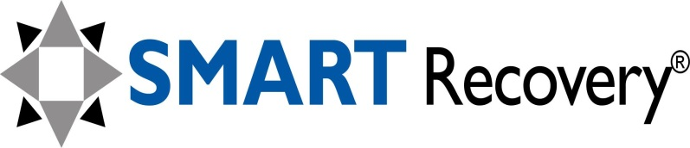
Teen and Youth Program

discover the power of choice…

